>> Push code into GitHub <<

>> Create repository in github
>> push code to github
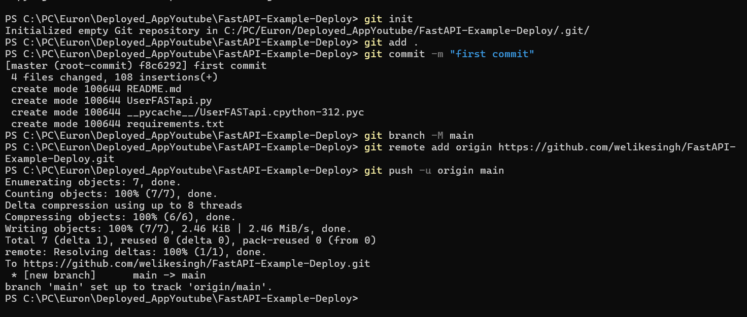

git init
git add .
git commit -m "first commit"
git branch -M main
git remote add origin https://github.com/welikesingh/FastAPI-Example-Deploy.git
git push -u origin main

>> Deploy application on Render Portal
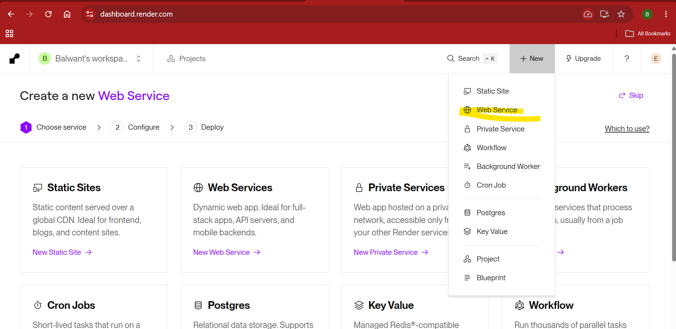

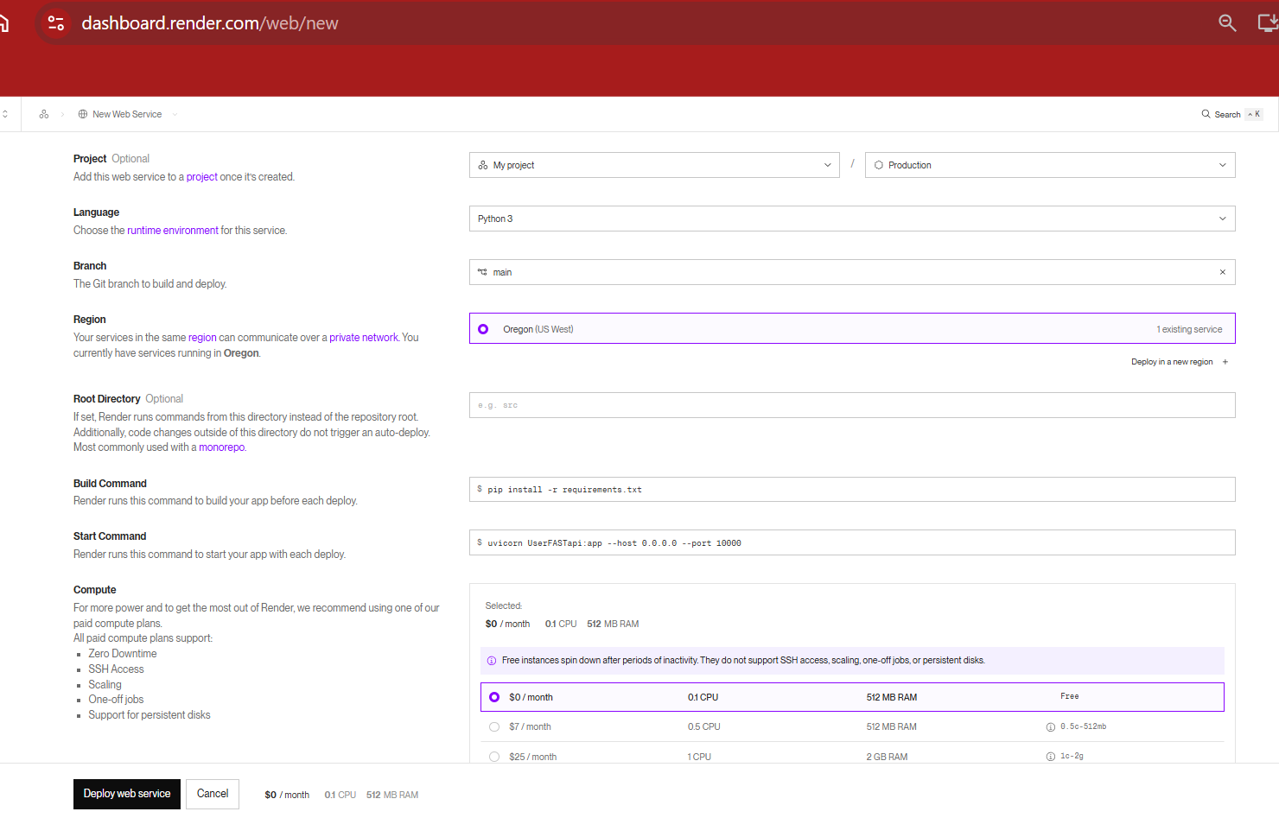

Collect URL: https://fastapi-example-deploy.onrender.com

